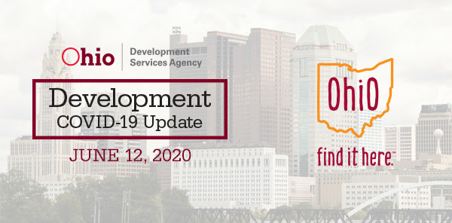

Ohio Distributes 30 Million Pieces of PPE
Governor Mike DeWine announced this week that Ohio has distributed more than 30 million pieces of personal protective equipment (PPE).
Sources of these resources include donations, the Federal Emergency Management Agency, JobsOhio purchases, and purchases by state agencies such as our departments of Administrative Services, Health, and Public Safety using federal CARES Act funds. Of the 30 million total PPE pieces, 27.8 million pieces have been shipped to county Emergency Management Agencies for local distribution.
The Ohio Bureau of Workers' Compensation “Protecting Ohio's Workforce – We've Got You Covered” program has sent more than 1.5 million face coverings to employers to support and enhance any workforce safety and health efforts that businesses already have in place.
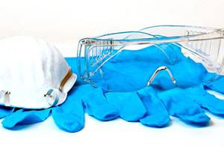
Ohio is also providing PPE to the Ohio Department of Mental Health and Addiction Services, through their Office of Pharmacy Services, to support requests for PPE from state agencies, boards, and commissions.
Ohio is currently looking at long-term solutions to PPE supply chain issues plaguing the country. This includes longer-term contracts for ventilators and N95 masks. Ohio is also currently evaluating the results of a recently issued Invitation to bid for gloves, gowns, and three-ply masks.
In addition, applications for the recently launched Ohio PPE Retooling and Reshoring Grant Program are being reviewed by the Development Services Agency. This program will provide awards of up to $500,000 to small and medium-sized manufacturers so they can repurpose existing facilities to make PPE or reshore PPE production to Ohio. These grants will allow small manufacturers and other entities an opportunity to create new business while contributing to the fight against COVID-19. For more information and to apply, click here.

$8.5 Million Grant to Help Workers and Employers
Lt. Governor Husted announced this week that the Ohio Department of Job and Family Services (ODJFS) will receive an $8.5 million federal Employment Recovery National Dislocated Worker Grant to help re-employ individuals who lost their jobs as a result of the COVID-19 pandemic and to help employers rebuild their workforces.
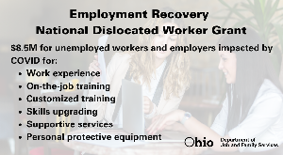
ODJFS will work with the Governor’s Office of Workforce Transformation to facilitate the grant program through local OhioMeansJobs centers and will distribute the funding to Ohio’s local workforce areas. ODJFS will also provide outreach to employers and services to individuals who were laid off, either permanently or temporarily, as a result of the pandemic.
To find your nearest OhioMeansJobs center, go to jfs.ohio.gov/county or visit
OhioMeansJobs.com and click on the icon for OhioMeansJobs centers. Ohioans also can visit coronavirus.ohio.gov/jobsearch and can click on “Find Jobs Near Me” to be taken to postings for essential jobs that employers need filled now.

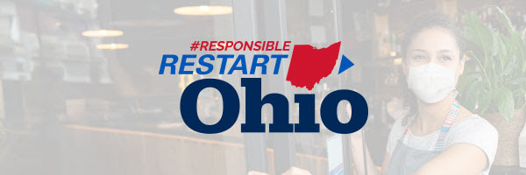

More Businesses and Venues Open Under Responsible RestartOhio
Businesses and venues throughout Ohio are opening under Governor DeWine’s Responsible RestartOhio plan. These businesses are reopening by using guidelines developed by industry advisory groups. Full guidelines to ensure that Ohio’s industry sectors operate in the safest manner possible are available at Coronavirus.Ohio.Gov.

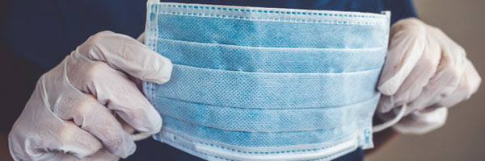

Reminder: Ohio Manufacturing Alliance Helps Businesses Find PPE
The Ohio Manufacturing Alliance to Fight COVID-19 created the Ohio Emergency PPE Makers’ Exchange as an online marketplace where organizations that need personal protective equipment (PPE) and related equipment can find a wide selection offered by Ohio manufacturers. This online service is especially well-suited for organizations that may have lower-volume needs.
For more information and to participate in the Exchange, click here.
The Alliance is a public-private partnership led by The Ohio Manufacturers’ Association, the Ohio Manufacturing Extension Partnership and its partner organization MAGNET, the Ohio Hospital Association, and JobsOhio, in partnership with the Ohio Development Services Agency, the Ohio Department of Administrative Services, and the Ohio Department of Health.
The Alliance also has created this list of practical things manufacturers need to be thinking about and do to prepare for COVID-19.
In addition to the resources available via the Ohio Manufacturing Alliance Makers’ Exchange, another list of vendors providing various PPE is available here (PDF).
DISCLAIMER: Third-party websites not controlled or monitored by Ohio Development Services Agency. Development is not responsible for any materials, information, or content posted on any linked third-party website. The inclusion of any links or contact information in this communication does not imply any relationship or association between Ohio Development Services Agency, the State of Ohio, and the listed business, nor is it an advertisement or endorsement. Information is provided for user convenience and information purposes only. You are responsible for your access to linked websites or contact of any individual or business.

We’re Here to Help Businesses Get Assistance
The Ohio Development Services Agency has many resources to help business owners make it through the current crisis and prepare for a strong future. Here are some of the resources, and most of them are offered at no cost to businesses.
- Small Business Development Centers: SBDC.Development.Ohio.Gov.
- Minority Business Assistance Centers: Minority.Ohio.Gov.
- Procurement Technical Assistance Centers: Find.GovContracts.Ohio.Gov.
- Manufacturing Extension Partnership: MEP.Development.Ohio.Gov.
- Export Assistance Network: ExportAssistance.Development.Ohio.Gov.
- Entrepreneurial Services Provider Program: ESP.Development.Ohio.Gov.

Akron Company Expanding to Produce More Sanitizing Products
GOJO Industries, an Akron-based manufacturer of hand sanitizer and other hygiene products, has been working with JobsOhio and this week announced that it is expanding in Navarre and Maple Heights to meet the demand for their products that are helping fight COVID-19.
The company, which is part of the Ohio Manufacturing Alliance, recently signed a lease for a facility in Navarre that will be used for storage and distribution. And on Tuesday, GOJO announced the purchase of a 325,000-square-foot facility in Maple Heights. GOJO Maple Heights will manufacture PURELL® Surface Spray. PURELL® Surface Spray was launched in 2016 combines being no-rinse on food contact surfaces with lowest possible toxicity while effectively killing bacteria, mold, mildew, fungi, and dozens of viruses, including Influenza and Norovirus.
These two new facilities bring the company’s Ohio manufacturing facilities to four, including those in Cuyahoga Falls and Wooster. GOJO headquarters is in Akron, Ohio, and the company also has several manufacturing facilities in France. GOJO employs more than 2,500 around the globe and is expecting to add at least 200 jobs with these two additional facilities.
Since the start of the pandemic, GOJO has more than doubled its production of PURELL® sanitizer, soap, wipes, and surface spray.
“GOJO is an Ohio-grown company whose products, including its PURELL® products are helping us combat the pandemic,” said Governor DeWine. “These new investments demonstrate the confidence GOJO has in Ohio’s talent, which is hard at work producing and distributing critical PURELL® products used worldwide.”
For more information, visit gojo.com.

We’re Pushing News and Information on Social Media
Development also is using its social media channels to raise awareness of programs and assistance available through the state and federal governments. We also are urging small businesses to reach out to Ohio Small Business Development Centers and Minority Business Assistance Centers around the state for help in applying for federal assistance and to plan for the future.
Follow us on Facebook, Twitter, Instagram, and LinkedIn.

For more information
Visit Coronavirus.Ohio.Gov/BusinessHelp or email BusinessHelp@Development.Ohio.Gov.

